Lab 5 Op-Amp Filters

In the last chapter, we discovered that the frequency response curve of op-amp circuits with resistive elements was dominated by the intrinsic frequency dependence of the op-amp. In this chapter, capacitive and inductive elements are introduced into the input and feedback loops. These elements have their own frequency dependence and they will dominate the frequency response of the gain curve. In many cases, the frequency response curve can be tailored to execute specialized functions such as filters, integrators and differentiators. Filters are designed to pass only specific frequency bands, integrators are used in proportional control circuits and differentiators are used in noise suppression and waveform generator circuits.

Impedance
A network of resistors, capacitors and/or inductors can be represented by the generalized impedance expression
Z = R + jX Equation 5-1
where R is the resistive component and X is the capacitive/inductive component called the reactance. The complex symbol j indicates that the reactive component is shifted in phase by 90˚ from the resistive component. Complex notation will be used in the analysis of op-amp circuits in this chapter. The voltage V and current I are in general a vector or a phasor with both real and imaginary terms.
Ohm's law tells us that there is a direct relationship between the voltage across a resistor and the current flowing through that resistor. Assuming that the AC current i = i_{o} sin(ωt), then the voltage across a resistor is
V_{R} = iR = i_{o} sin(ωt) R Equation 5-2

where ω = 2πf and f is the frequency measured in cycles per second or Hertz. The amplitude of V_{R} is just (i_{o}R). Resistance is real and always positive. In complex notation, the voltage across a resistor is
V_{R} = i_{o}R exp(jωt) Equation 5-3
For an inductor, the magnitude of the reactance or equivalent resistance X_{L} is (ωL). Lenz's law tells us that the voltage across an inductor is proportional to the derivative of the current. Assuming that the current is given by i = i_{o} sin(ωt), then the voltage across the inductor is
V_{L} = L (di/dt) = L ω i_{o} cos(ωt) Equation 5-4
Recalling that cos(x) = sin(x+90˚), then equation 5-3 becomes
V_{L} = i_{o} sin(ωt+90˚) (ωL) Equation 5-5
This expression look like Ohm's law, equation 5-2 where (ωL) is the equivalent of 'resistance' but with a phase shift of 90˚. The equivalent complex 'resistance' is called the reactance X_{L} = jωL and the 90˚ phase shift is represented by the complex operator j. In complex notation
V_{L} = (jωL) i_{o}exp(jωt) Equation 5-6
For a capacitor, the magnitude of the reactance or equivalent resistance X_{C} is (1/ωC). The charge Q on a capacitor is directly proportional to the voltage across the capacitor (Q = CV). Recalling the definition of current i = dQ/dt, one can write this relationship as
i = C (dV/dt) Equation 5-7

Solving for V in equation 5-7 and integrating yields
V_{C} = (1/C) ∫ i_{o}sin(ωt) dt = (1/ωC) i_{o}(- cosωt) Equation 5-8

With the identity -cos(x) = sin(ωt - 90˚), then
V_{C} = (1/ωC) i_{o} sin (ωt-90˚) Equation 5-9

This expression look like Ohm's law, equation 5-2 where (1/ωC) is the 'resistance' but with a phase shift of - 90˚. The equivalent complex 'resistance' is called the reactance X_{C} = 1/jωC and the 90˚ phase shift is represented by the complex operator j. In complex notation
V_{C} = (1/jωC) i_{o}exp(jωt) Equation 5-10

In summary

Resistance (R) is real and its magnitude is R.
Reactance for an inductor (X_{L} = jωL) is imaginary and its magnitude is ωL.
Reactance for a capacitor (X_{C} = 1/jωC) is imaginary and its magnitude is 1/ωC.

Low Pass Filter
A simple low pass filter can be formed by adding a capacitor C_{f} in parallel with the feedback resistor R_{f} of an inverting op-amp circuit.
Figure 5-1 Low Pass Op-Amp Circuit

Recall that 'resistors' in parallel add as reciprocals. Hence the feedback network of these components can be represented by a single feedback impedance Z_{f} where
1/Z_{f} = 1/R_{f} + 1/ X_{c} Equation 5-11
Inverting and rationalizing leads to the expression
Z_{f} =(R_{f} - jω C_{f} R_{f}²)/(1+ω² C_{f} ²R_{f}²) Equation 5-12
The feedback impedance has both a real and an imaginary term, both of which are frequency dependant. The voltage transfer equation can be written as
V_{out} = (Z_{f} /R₁) V_{in} Equation 5-13
Solving for the gain (V_{out}/V_{in}) leads to a simple equation
G(f) = G(0)/√(1+f²/f_{u}²) Equation 5-14
where G(0) = (R_{f} /R₁) is just the closed loop gain with no capacitor. This equation looks suspiciously like the intrinsic frequency dependence of the op-amp, equation 4-5. And it is, except that now upper frequency cutoff point f_{u} is related to the feedback network and given by
2πf_{u} = 1/ R_{f} C_{f} Equation 5-15
The closed loop cutoff point is always less than the open loop frequency cutoff. Note as before, the gain falls to 1/2 or -3 dB at f_{u} and the filter bandwidth is just f_{u}.
LabVIEW Demo 4.1 Simple Low Pass Filter
Load the program called LowPass.vi from the chapter 5 program library. Click on the [Run] button to see the Bode plot. Investigate the position of the upper frequency cutoff point as the feedback capacitor or feedback resistor is varied. Note the response curve when the gain G(0) is changed by varying R₁or R_{f}. For convenience the open loop curve with A(0) = 100 dB and an open loop cutoff frequency at 10 Hertz is also shown.

Figure 5-2 Bode Plot of an Op-Amp Low Pass Filter
All frequencies with f is less than f_{u} have a constant gain while all frequencies with f greater then f_{u} are attenuated. A filter which displays this property is called a low pass filter. For high frequencies, one notes that the response curve rolls off with the same slope of -20 dB/decade as the open loop response curve. What is happening here?
Look at the feedback network impedance in the limits where f<f_{u} and f>f_{u}. Calculating Z_{f} or using the LabVIEW vector calculator shows in the limit of
low frequencies (f< f_{u}), Z_{f} -> R_{f} Equation 5-16
high frequencies (f> f_{u}), Z_{f} -> 1/j2πfC_{f} Equation 5-17
At low frequencies, the reactance of the capacitor is so large, that all the current flows through R_{f} and the gain is just (R_{f}/R₁). At high frequencies, the capacitor reactance is low and the current readily flows through the capacitor not the resistor. Now the gain is (1/j2πf R₁C_{f}) and falls off inversely with frequency. On the Bode plot, this region is a straight line with a negative slope of 20 dB/decade.
When a square wave is integrated, what waveform do you find? That is right, a triangular wave. Just like in Lab 2 for the DC integrator, the capacitor C_{f} allows charge to accumulate on the feedback capacitor in the region where f> f_{u}. A low pass filter in this frequency range integrates the waveform so that a square wave input becomes a triangular wave output. AC integrators find extensive use in analog computation circuits.

High Pass Filter
A simple high pass filter can be formed by adding a capacitor C₁ in series with the input resistor R₁ of an inverting op-amp circuit.
Figure 5-3 High Pass Op-Amp Circuit

Recall that 'resistors' in series add serially. The input network of components can be represented by a single feedback impedance Z₁ where
Z₁ = R₁ +X_{c} Equation 5-18
Substituting the definition of reactance for a capacitor leads to
Z₁ =(R₁- 1/jω C₁) Equation 5-19
The complex transfer equation for gain can be written as
V_{out} = (R_{f} / Z₁) V_{in} Equation 5-20
Solving for the gain (V_{out} / V_{in}) leads to
G(f) = G(0)/√(1+f_{l}²/f²) Equation 5-21
where G(0) = R_{f} /R₁ . This is similar in form to the previous equation (5-13) except that the frequency ratio is inverted. Here f_{l} is a low frequency cutoff point and is governed by the input components R₁,C₁ and the equation
2πf_{l} = 1/ R₁C₁ Equation 5-22

In this configuration, the op-amp circuit is AC coupled and no DC signal can pass. Only AC signals with a frequency greater than the low frequency cutoff point will be amplified fully. Note at f = f_{l}, the gain has fallen to 1/2 or -3 dB. The filter bandwidth is now (f_{u} - f_{l}) where f_{u} is the closed loop gain upper cutoff frequency.

LabVIEW Demo 5.2 Simple High Pass filter
Load the program called HighPass.vi from the chapter 5 program library. Click on the [Run] button to see the Bode plot. Investigate the position of the low frequency cutoff point as the input capacitor or resistor is varied. Note also the response curve when the gain G(0) is changed by varying R₁or R_{f}. For convenience the open loop curve with A(0) = 100 dB and an open loop cutoff frequency at 10 Hertz is also shown.

Figure 5-4 Bode Plot of an Op-Amp High Filter
All frequencies greater than f_{l} have a constant gain (up to the open loop cutoff) while all frequencies less than f_{l} are attenuated. A filter which displays this property is called a high pass filter. For low frequencies, the response curve rolls off with a slope of 20 dB/decade. What is happening here?
Look at the input network impedance in the limits where f< f_{l} and f>f_{l}. Calculating Z₁ or using the LabVIEW vector calculator show that in the limit of
low frequencies (f< f_{l}), Z₁ -> 1/j2πfC₁ Equation 5-23
high frequencies (f> f_{l}), Z₁ -> R₁ Equation 5-24
At low frequencies, the reactance of the capacitor is so large that current is strongly attenuated and the gain (j2πf R_{f}C_{f}) increases linearly with frequency up to f_{l}. On the Bode plot, this region is a straight line with a positive slope of 20 dB/decade. At high frequencies, the capacitor reactance is low and the current readily flows through the input capacitor. The gain acts as if there were no capacitor in the input loop and the gain is constant (R_{f} /R₁) up to the open loop frequency response curve.

What happens when a triangular waveform is applied to a high pass filter in the region where the gain is frequency dependent? That's right, the output is a square wave. The harmonic components of the triangular wave are strongly modified so that the input signal is differentiated. AC differentiators find extensive use in analog computation circuits and noise suppression circuits.

Bandpass Filter
A bandpass filter passes all frequencies between two cutoff points at a low and a high frequency. An ideal bandpass filter would be infinity sharp at the cutoff points and flat between the two points. Real bandpass filters with names like Chebyshev, Butterworth and Elliptic come close to the ideal but never quite make it. A simple bandpass filter can be made by combining the simple high pass and low pass circuit of the previous sections.
Figure 5-5 Schematic Diagram of a Op-Amp Bandpass Filter

Both the input and feedback loop impedances are now complex and the gain is
G(f) = |Z_{f} /Z₁| Equation 5-25
Solving this gives the frequency dependent gain
G(f) = G(0) /[√(1+f_{l}²/f²)][ √(1+f²/f_{u}²)] Equation 5-26
with a low frequency cutoff point f_{l} (equation 5-22) and a high frequency cutoff point f_{u} (equation 5-15). The bandwidth of the band pass filter is given from the intersection points of the -3 dB line with G(f) or simply BW = (f_{u}-f_{l}).

LabVIEW Demo 5. 3 Simple Band Pass filter
Load the program called BandPass.vi from the chapter 5 program library. Click on the [Run] button to see the Bode plot. Investigate the shape of the band pass filter curve when the key components R₁, C₁, R_{f} or C_{f} are varied. For convenience the open loop curve with A(0) = 100 dB and an open loop cutoff frequency at 10 Hertz is also shown.

Figure 5-6 Bode Plot of an Op-Amp Bandpass Filter
What shape does the bandpass filter response curve take when f_{u} = f_{l}?
Such a curve selects one frequency above all the others.
LabVIEW Challenge:
What happens when a square wave is used as the source waveform V_{in} for a low pass filter?

A square wave is made up of a fundamental sine wave at frequency f and higher odd harmonics at 3f, 5f ,7f etc. The amplitudes of each frequency component are 1, 1/3, 1/5, 1/7 etc. When a square wave is applied to the filter in the region where the gain is frequency dependent, the harmonics are rapidly attenuated, so much so that the output voltage is modified or filtered into a triangular waveform.

Design a LabVIEW program which adds the fundamental and three harmonics of a square wave and is displays the resultant waveform for one complete cycle. Apply this waveform to an op-amp with a gain of 1000 and an upper cutoff frequency at the waveform fundamental frequency. What is the amplitude for each component? Add these components to see an approximation of a triangular wave

eLab Project 5
Objective: To study the frequency response of a bandpass filter and its dependence on a series capacitor in the input loop and a parallel capacitor across the feedback resistor.

Procedure: Build a real bandpass filter using the circuit shown below. With a function generator as a source of sine waves measure the frequency characteristics and determine the Bode plot.

Figure 5-7 Schematic Diagram of a Bandpass Filter

The circuit requires a 741 op–amp, two resistors, two capacitors and two power supplies. Choosing R_{f} = 100 kΩ and R₁ = 10 kΩ gives the closed loop gain of 10 or 20 dB in the bandpass frequency region. Chose C₁ = 1μf and C_{f} = 0.001μf. Chose a function generator set to sine wave with an amplitude of 50 mV as the input voltage V_{in}. Component layout is shown on the next page.

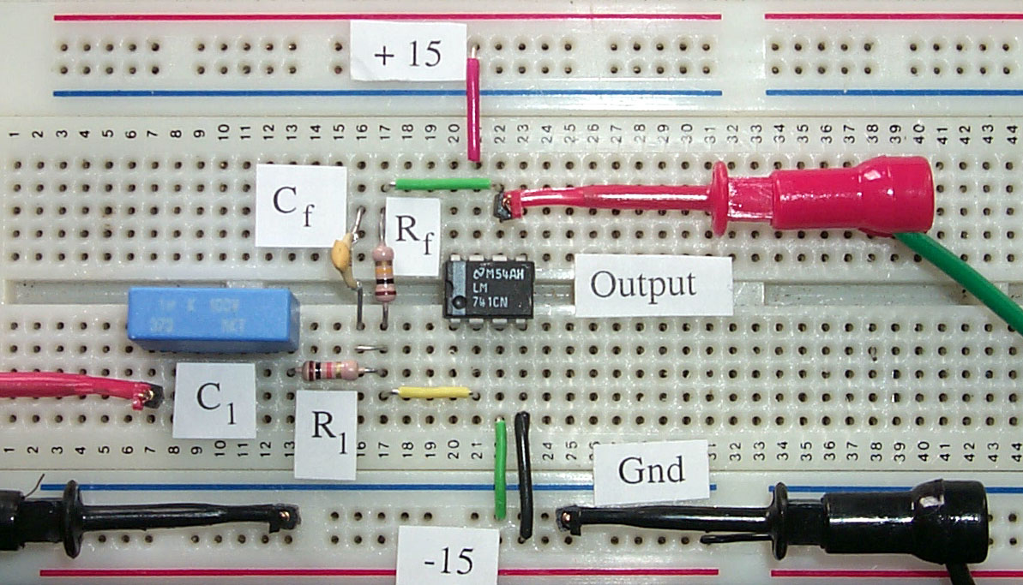

Figure 5-8 Component Layout of an Op-Amp Bandpass Filter

Use an oscilloscope or a high speed DAQ card to measure the output signal level. In all cases, it is wise to measure the input signal level and compute the gain from the expression V_{out}/V_{in}. In choosing the test frequencies, select the decade range then measure at multiples of 1, 2, 4, and 8. This gives an approximately uniform set of points on a log f scale. Graph the Bode plot, that is the gain in decibels as a function of log₁₀ of the frequency.
From the key variables R₁, C₁, R_{f} or C_{f} calculate the lower and upper frequency cutoff points. How do these points compare with the actual measured -3dB points on the Bode plot?

Computer Automation 5 : Response to Stimulus Signals

Computer automation is all about the automated measurement, analysis and reporting of the response of devices or systems under test. For AC stimulus, the response of interest could be the amplitude, the frequency or the phase content. In all cases, a representative sample of the signal in the form of an array is the most convenient to analyse. LabVIEW has many array VIs that enable the amplitude to be measured in units of peak, peak-peak, average or rms signal level. The frequency of sinusodial signals can be measured eloquently with frequency, period or counter VIs. The harmonic content of more complex stimulus signals can be analysed with FFT or Power Spectrum VIs. Phase measurements require a reference signal and it is best to store the reference and response signals as an array. In this lab, we look on at sinusodial stimulus signals applied to a bandpass filter and observe the response on a LabVIEW graph.

Launch the LabVIEW program entitled Response 5.vi from the chapter 5 library. This program uses an input channel on the DAQ card to measure the circuit response signals. Connect a waveform generator sinusodial output (1volt peak signal level) to the input (pin 3) of the bandpass filter, eLab 4. Choose components so that the low frequency cutoff is about 50 Hertz. Click on [Run] to start the data collection and observe the waveform as the stimulus is varied from 1 to 100 Hertz. Adjust the stimulus frequency until the measured response is –3dB below the input level. This frequency is the low frequency cutoff point. How does it compare with the value predicted from equation 5.21?

LabVIEW Enhancements:

Design a LabVIEW VI to determine the peak, peak-peak or rms signal amplitude.
Replace the waveform generator with a LabVIEW generator.
Design a LabVIEW VI to automatically sweep the input frequency and determine the low frequency cutoff point.

